**How to access the data?**

**Go to:** <http://roads.data.tfl.gov.uk> 🡪 TIMS

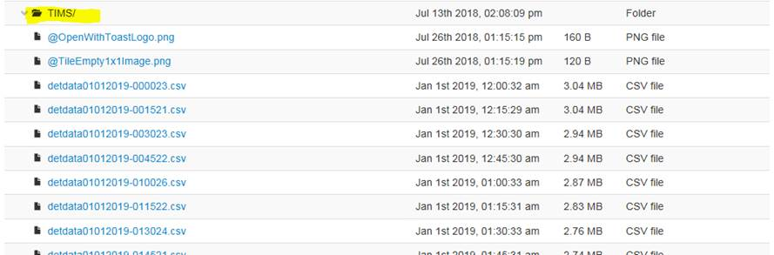

TIMS data:

This data comes from inductive loops that are part of TfL’s SCOOT system which controls traffic signals (over 5400 junctions). This data shows approximation of traffic flows coming through a junction, as well as a level of congestion (~total traffic through / capacity). Each file is uploaded every 15 minutes, but includes 15 data points for each junction / node for every minute (~15min moving average). See example below.

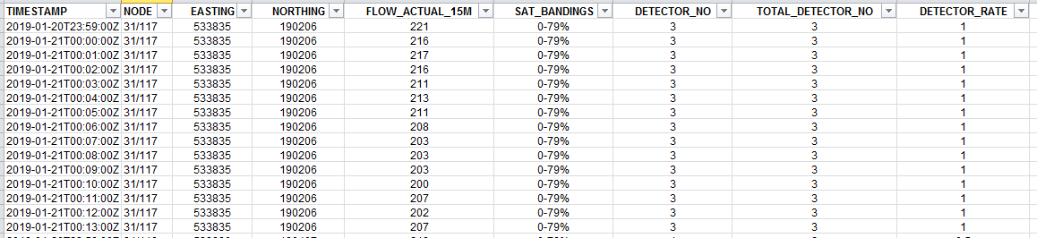

Data description:

1. TIMESTAMP
2. NODE
3. EASTING
4. NORTHING
5. FLOW_ACTUAL_15M = **Average** flows for past 15minutes per each *working* detector which belongs to a given node & for which the data is available
6. SAT_BANDINGS = **Average** Saturation for past 15minutes from all *working* detectors which belong to a given node & for which the data is available → converted to bands:
   * 0-79%
   * 80-89%
   * 90-99%
   * >=100%
   * No Data
7. DETECTOR_No – Number of detectors that belong to each node & that data is available
8. TOTAL_DETECTOR_NO – Total No of detectors that belong to each node
9. DETECTOR_Rate = % of detectors from each node the data comes from = (TOTAL_DETECTOR_NO / DETECTOR_No)

A few Q&As:

What is FLOW_ACTUAL_15M?

These are average “flows” for the past 15 minutes *per working detector*- it’s a moving average.

Please keep in mind that these are only proxies of real flows, so it’s probably best to use this data to compare against each other, analyse trends rather than take the flows at a face value.

The aggregation of the data means that, unfortunately, we don’t know which arm carries most of the traffic. TfL is working towards releasing a disaggregated version of this data for each node through an API (TBC).

Node vs junction vs detector:

Each junction / node consists of +1 detector. So the DETECTOR_NO is the number of *working* detectors for a given site. The idea behind providing this information was that one could:

* normalise flows for all working detectors, by multiplying FLOW_ACTUAL_15M x DETECTOR_NO
* estimate total flows for all detectors, by multiplying FLOW_ACTUAL_15M x TOTAL_DETECTOR_NO

Here is an example showing relation between nodes vs detectors. Node N00/002 consists of 7 detectors:

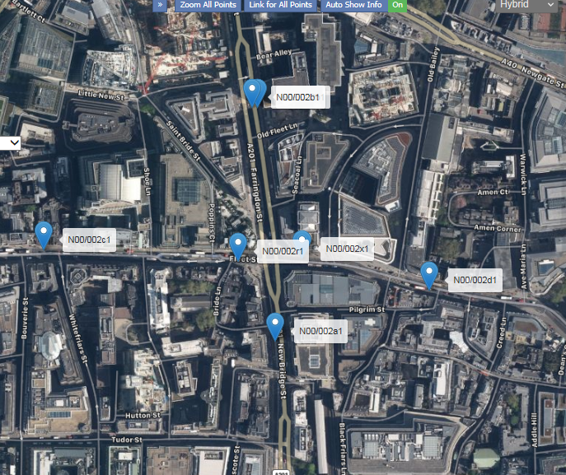

Is there anything that implies direction?

Unfortunately, there isn’t. In the example above, all you would see from the dataset is congestion / “flows” for a node N00/002. You wouldn’t be able to know how much traffic comes from the West (N00/002c) vs East (N00/002d) or which detector is working. (Perhaps the API will include data for each detector rather than average / node)

Column “TOTAL_DETECTOR_NO” implies that there is more than one detector counting; thus is the count just from one of the detectors on site?

* Yes, as mentioned above, each site / node can have multiple No of detectors.
* Not all inductive loops work 100% of the time; Most are placed over 1 traffic lane, but there are some (small number) that cover 2 lanes.
* By knowing how many detectors work and how many don’t, one can estimate the quality of the data for a given junction and estimate total flows

